**INSTITUTE OF MANAGEMENT SCIENCES, PESHAWAR**

**MID TERM ASSESSMENT**

**Database Systems (Lab)**

**Date/Time: 28th April , 2021 – 12:30 pm – 1:30 pm**

**Instructions:**

1. Create a Word Document for submission.
2. Any paper submitted after 1:30 pm will not be accepted.
3. Queries shouldn’t be copied from any source.
4. Read your paper carefully before starting.
5. Submit the queries your perform in order to complete each part of question.

**1.a** Create a database YourName (Basit)

[1 Mark]

Create database Maimoona_Khilji;

**1. b** Create the following tables using SQL Commands.

[6 Marks]

**Guidelines for Q1. b**

1. Select appropriate datatype for each attribute.
2. Identify keys.
3. Autoincrement *PID* and *TID*.
4. Default Patient treatment *Date* should be your date of birth.
5. System should check *P_Name* should be (Your Name OR Your Father Name OR Your Grandfather Name) if any other value inserted in P_Name system should give an error while insertion.
6. Attach screenshot of each table schema (Table Structure MySQL Workbench)

CREATE table patient (

PID int PRIMARY KEY auto_increment,

p_Name varchar(255)

CHECK ( P_Name in ("Maimoona Khilji","Naseer Ahmad","Saleem Ahmad" ) )

);

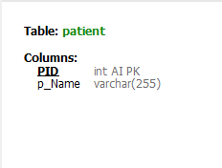

CREATE TABLE Treatment(

TID int PRIMARY KEY auto_increment,

T_Name varchar(255)

);

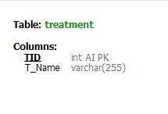

CREATE TABLE patient_treatment(

Date date DEFAULT "2001-08-04",

PID int,

TID int,

Foreign key (PID) references Patient (PID),

Foreign key (TID) references Treatment(TID)

);

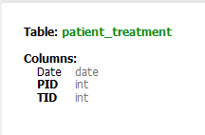

Table structures

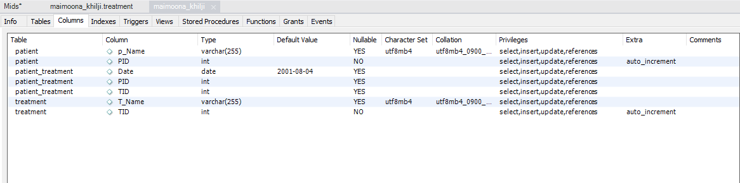

**1c.** Write query to insert 1 valid record in each table (Patient, Patient_Treatment, Treatment ).

[3 Marks]

**Guidelines for Q1. c**

Where in First table the name of patient should be your name & In treatment table you should enter any disease name starting with the first alphabet of your name.

Sample Output of Patient & Treatment Table:

Patient

|  |  |
| --- | --- |
| PID | P_Name |
| 1 | Basit |

Treatment

|  |  |
| --- | --- |
| TID | T_Name |
| 20 | Blood Clot. |

# I just entered the name, as PID is auto-incremented so it will automatically start with 1

INSERT INTO Patient(P_Name)

VALUES ("Maimoona Khilji" );

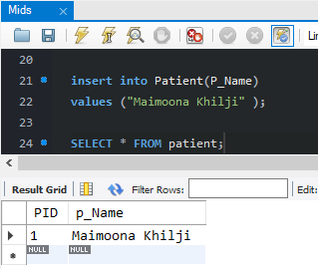

#we can manually insert the data into auto-incremented column as well.

insert into treatment

values (4,"Malaria");

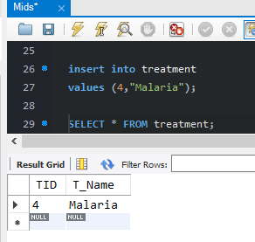

#I inserted the data of PID and TID. As for date I already used default function so I can insert only into these two columns without inserting into the date column.

INSERT INTO Patient_treatment (PID,TID)

values (1, 4 );

Note: here date is default date that is my date of birth.

